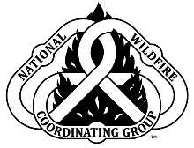
NWCG S-131, Firefighter Type 1

[Host]

[Date]

[Location]
Day 1
30 Minutes | Course Introduction | [Instructor Name]
1 Hour | Unit 1: Position Responsibilities and Operational Leadership | [Instructor Name]
1 Hour | Unit 2: Communication | [Instructor Name]
2 ½ Hours | Unit 3: LCES  Lookouts, Communications, Escape Routes, and Safety Zones | [Instructor Name]
2 ½ Hours | Unit 4: Look Up, Down, and Around | [Instructor Name]
Day 2
4 Hours | Unit 5: Decision Making | [Instructor Name]
1/2 Hour | Student Assessment | [Instructor Name]

